Pythagorean Theorem Problems

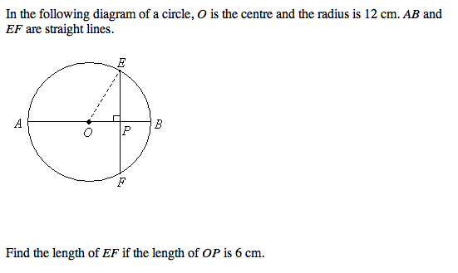

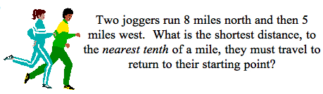
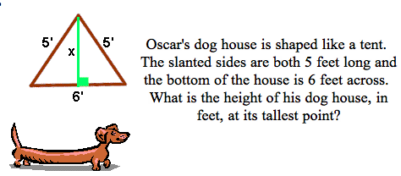

A baseball diamond is a square with sides of 90 ft. What is the shortest distance, to the nearest tenth of a foot, between first base and third base?

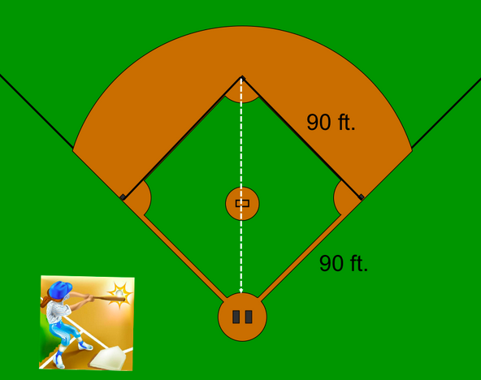

An 11m ladder is leaned up against a wall. The base of the ladder is place 4m from the wall. How far up the wall will the ladder reach?
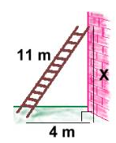

Calculate the area of the triangle.

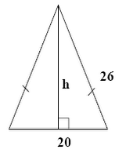

Mrs. Minty purchases an old school cathode ray tube television that is 60 inches high and 80 inches across. Most TVs are sold with the description of their diagonal distance. If this TV was advertised in a flyer, what would it be?

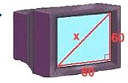

Calculate the length of “b”.

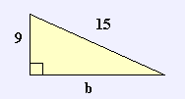

What is the length of the diagonal in a square with sides of 1m?

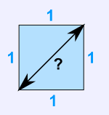

Jordan has to walk around a nearby pond. In his mind, he is frustrated that he has to go around and can’t stop thinking about the shorter distance he could have been walking if he had gone in a straight line from point A to point B. What would this distance be?
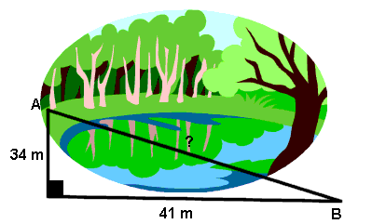

Calculate the value of “c”.

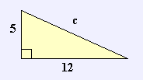
Is the triangle below, a right angle triangle? How do you know?

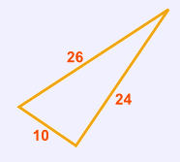

John leaves school to go home. He walks 6 blocks North and then 8 blocks west. How far is John from the school?

Determine the side of an equilateral triangle whose perimeter is equal to a square of side 12 cm. Are their areas equal?

Determine the area of the square inscribed in a circle with a circumference of 18.84 cm.

