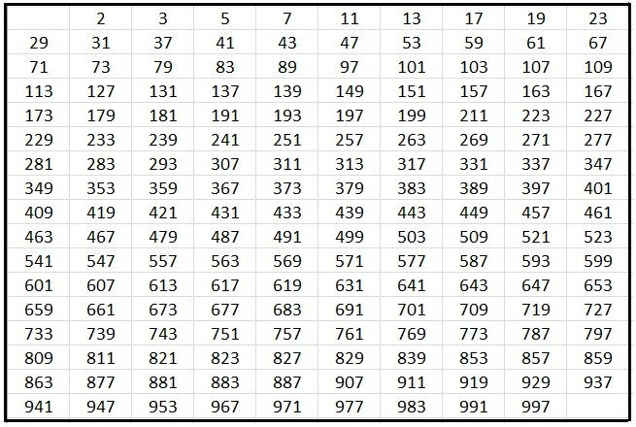
PRIME NUMBERS TO 100

