More Challenging Pythagorean Word Problems

Shane marched 3 m east and 6 m north. How far is he from his starting point?

The rectangle PQRS represents the floor of a room.
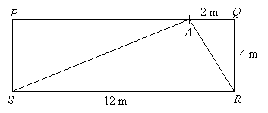
Ivan stands at point A. Calculate the distance of Ivan from
a) the corner R of the room
b) the corner S of the room

In the following diagram of a circle, O is the centre and the radius is 12 cm. AB and EF are straight lines.
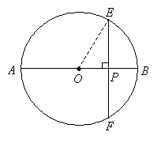

Find the length of EF if the length of OP is 6 cm.
A triangle has sides 4 m, 5 m, and 6 m. What is the measure of the longest side of a similar triangle whose shortest side is 16 m?

A triangle has sides 7 in., 10 in., and 11 in. What is the measure of the shortest side of a similar triangle whose longest side is 33 in.?

The foot of a ladder is placed 6 feet from a wall. If the top of the ladder rests 8 feet up on the wall, how long is the ladder?

Donna's TV screen is 20 inches long. If the diagonal measures 25 inches, how long is the width of Donna's TV?

Town A is 9 km from town B, and 12 km from town C. A road connects towns B and C directly. Find the length of this road.

If the legs of an isosceles right triangle are 5 inches long, approximate the length of the hypotenuse to the nearest whole number.

Scott wants to swim across a river that is 400 meters wide. He begins swimming perpendicular to the shore he started from but ends up 100 meters down river from where he started because of the current. How far did he actually swim from his starting point?

In construction, floor space must be given for staircases. If the second floor is 3.6 meters above the first floor and a contractor is using the standard step pattern of 28 cm of tread for 18 cm of rise then how many steps are needed to get from the first to the second floor and how much linear distance will need to be used for the staircase?

How long would a railing be that was parallel to the steps in the previous question?

In the Old West, settlers often fashioned tents out of a piece of cloth thrown over tent poles and then secured to the ground with stakes forming an isosceles triangle. How long would the cloth have to be so that the opening of the tent was 4 meters high and 3 meters wide?

If the height of a triangle is five cm less than the length of its base, and if the area of the triangle is 52 square cm, find the base and the height.

If the sum of the sides of a right triangle is 49 cm and the hypotenuse is 41 cm, find the two sides.

