UNIT #1 SQUARE ROOTS & SURFACE AREA

**1.** Determine the value of each of the following to the nearest tenth.

**a)**  **b)** 

**2.** Write the value of each expression in the form .

**a)**  **b)** 

**3.** Between what two whole numbers does the square root of 24 lie?

**4.** Determine the number that has a square root of 2.3.

**5.** Determine whether each rational number is a perfect square. If it is a perfect square, write the product as an expression of two equal rational factors.

**a)** 0.9 YES NO __________

**b)**  YES NO __________

**c)**  YES NO __________

**d)** 0.81 YES NO __________

**e)**  YES NO __________

**f)** 1.44 YES NO __________

**g)** 0.0001 YES NO __________

**h)**  YES NO __________

**6.** The cube has a side length, *s*, of 10 cm. The cylinder has a height, *h*, of 10 cm and a radius, *r*, of 10 cm. Determine the surface area.

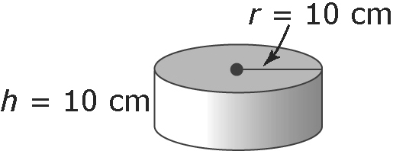

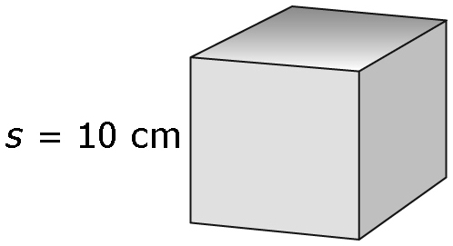

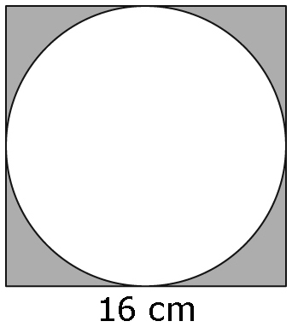**7.** The diagram shows a circle inscribed in a square with a side length of 16 cm. What is the area of the shaded region? Give your answer to the nearest hundredth of a square centimetre. Show your work.



**8.** A barn is built in the shape of a right rectangular prism with a semi-circular roof. Determine the surface area of the barn (do not include the base that is touching the ground). Give your answer to the nearest whole number.

UNIT #2 POWER & EXPONENT LAWS

**1.** In the equation –(–2)5 = –32, which number represents the base of the power?

**A** –32 **B** –2 **C** –1 **D** 2

**2.** Which expression is equivalent to (–2) × (–2) × (–2) × (–2) × (–2)?

**A** 25 **B** 32 **C** (–2)5 **D** –(–2)5

**3.** What is the product of 52 and 54?

**A** 650 **B** 256 **C** 58 **D** 56

**4.** Devin was asked to simplify the expression 10 – 23 × (3 – 20)2. His work is shown below.

10 – 23 × (3 – 20)2

= 10 – 6 × (3 – 1)2 Step 1

= 10 – 6 × 4 Step 2

= 10 – 24 Step 3

= –14 Step 4

In which step did Devin make his first mistake?

**A** Step 1 **B** Step 2 **C** Step 3 **D** Step 4

**5.** Two students were asked to write each product of powers as a single power. Their work is shown below.

|  |  |
| --- | --- |
| **Danica**  33 × 32 = (3 × 3 × 3) (3 × 3)  = 35 | Frank  33 × 32 = 33 × 2  = 36 |

Which of the following statements about their procedures istrue?

**A** Frank’s procedure contains an error and Danica’s does not.

**B** Danica’s procedure contains an error and Frank’s does not.

**C** Both Danica and Frank have no errors in their procedure.

**D** Both Danica and Frank have errors in their procedure.

**6.** The value of 33 + 30 is __________

**7.** The expression  written as a fraction in simplified form is ___________

**8.** Arrange the powers in order from smallest value to largest value. (–4)2, (2)3, –(4)3, (–1)5

**9.** Write each expression as repeated multiplication.

**a)** 37 **b)** –(–6)5 **c)** (4 × 5)3

**10.** Write each expression as a power in simplified form.

**a)** 67 ÷ 64 **b)** (22 + 3)4 **c)** 

UNIT #3 RATIONAL NUMBERS

**1.** Four students were asked to write the numbers , , , 0.72, and  in ascending order. Which student wrote the numbers in the correct order?

**A** Albert : , , , 0.72,  **B** Beth: , , , , 0.72

**C** Carmella: , , 0.72, ,  **D** Devin: , , , 0.72, 

**2.** Which rational number is between −1.06 and −1.07 on a number line?

**A**  **B**  **C**  **D** 

**3.** Colin was asked to simplify the expression . His work is shown below.

**Step 1**  –  = (6 – 3) – 

**Step 2** = 3 – 

**Step 3** = 2 – 

**Step 4** = 

In which step did Colin make his first mistake?

**A** Step 1 **B** Step 2 **C** Step 3 **D** Step 4

**4.** Which rational number is not an example of a square number?

**A** 196 **B** 0.0169 **C**  **D** 

**5.** A decimal number, to the nearest tenth, between  and  is ________________

**6.** The value of the expression 3.7 – 4.6 ÷ (–2.3) + 1.7 is _____________

**7.** Calculate. Show your work.

**a)**  **b)**  **c)** 

**d)**  **e)**  **f)** 

**g)**  **h)** 

**8.** Identify the rational numbers.

**a)** 17  −3.606  – **b)** –0.2    7.1234…

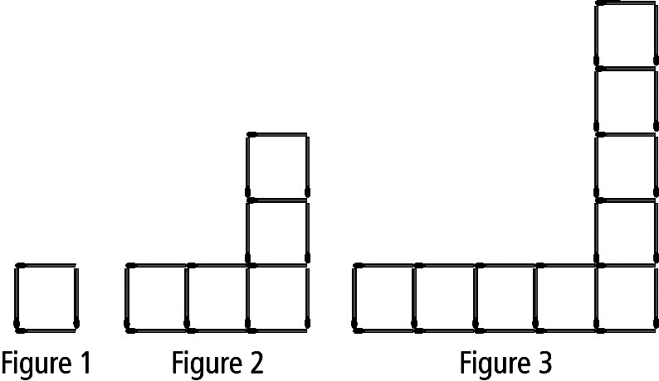UNIT #4 LINEAR RELATIONS

**1.** Which equation best represents the relationship between the number of matches, *m*, and the figure number, *f* ?

**A** *m* = *f* + 3 **B** *m* = *f* + 12

**C** *m* = 4*f* – 3 **D** *m* = 12*f* – 8

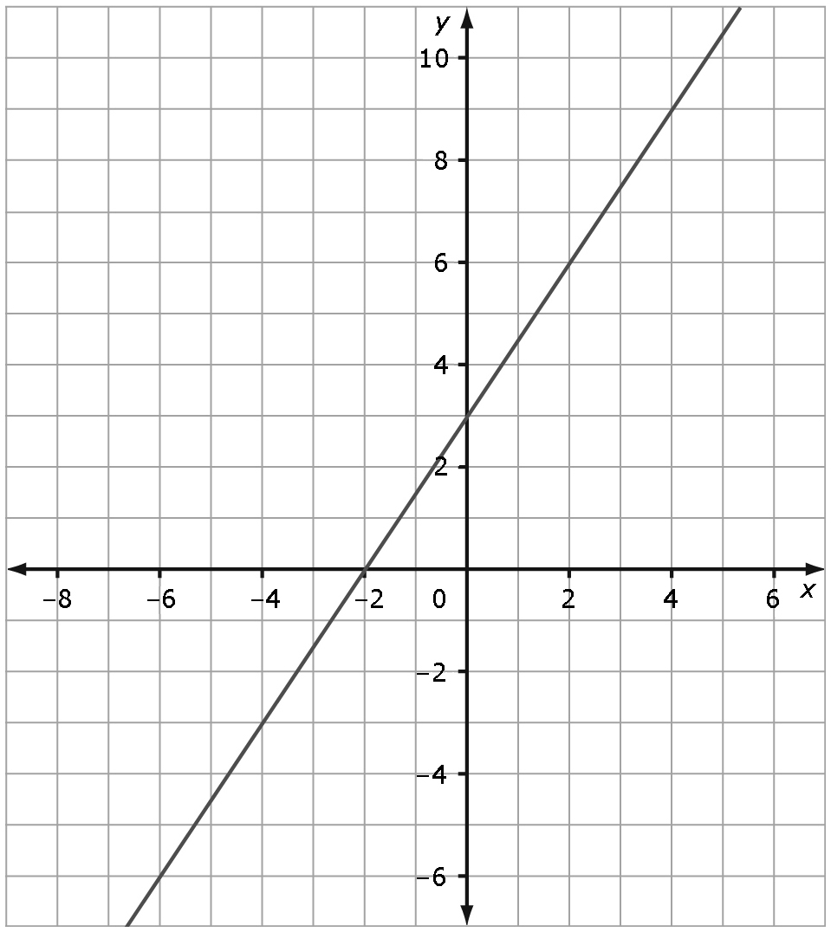**2.** Which table of values best represents   
this graph of a linear relation?

|  |  |  |
| --- | --- | --- |
| **A** | ***x*** | ***y*** |
|  | –2 | 0 |
|  | 0 | 3 |
|  | 2 | 6 |
|  | 4 | 9 |

|  |  |  |  |
| --- | --- | --- | --- |
| **C** | ***x*** | | ***y*** |
|  | –2 | | 0 |
|  | 0 | | 3 |
|  | 2 | | 9 |
|  | 4 | | 27 |
| **B** | | ***x*** | ***y*** | | |
|  | | –2 | 0 | | |
|  | | 0 | 3 | | |
|  | | 2 | –6 | | |
|  | | 4 | –9 | | |

|  |  |  |
| --- | --- | --- |
| **D** | ***x*** | ***y*** |
|  | –2 | 0 |
|  | 0 | 3 |
|  | 2 | –9 |
|  | 4 | –27 |

*Complete the statements in #3 and 4, using the graph in #2.*

**3.** When *x* = 4, the approximate *y*-coordinate is ____.

**4.** When *y* = –6, the approximate *x*-coordinate is ____.

**5.** The yearbook committee is pricing the yearbook. The printing company charges a flat fee of $7 per book plus $0.03 per page. Write a linear equation to represent the relationship between the number of pages in the yearbook and its cost.

|  |  |
| --- | --- |
| **Tips ($)** | **Total Earnings ($)** |
| 20.00 | 65.00 |
| 50.00 | 87.50 |
| 100.00 | 125.00 |

**6.** Amanda works as a waitress. She earns $50 a day plus 75% of the tips her customers leave. (The rest of the tips go to the kitchen staff and bussers.) The table of values represents Amanda’s earnings on different days.

**a)** Write a linear equation that represents the relationship between earnings and tips.

**b)** Verify the equation.

**7.** Alex runs at an average speed of 6 km/h. The equation relating distance, *d*, and time, *t*, is *d* = 6*t*.

**a)** Graph the linear relation.

**b)** Use the graph to estimate how long it takes Alex to run 10 km.

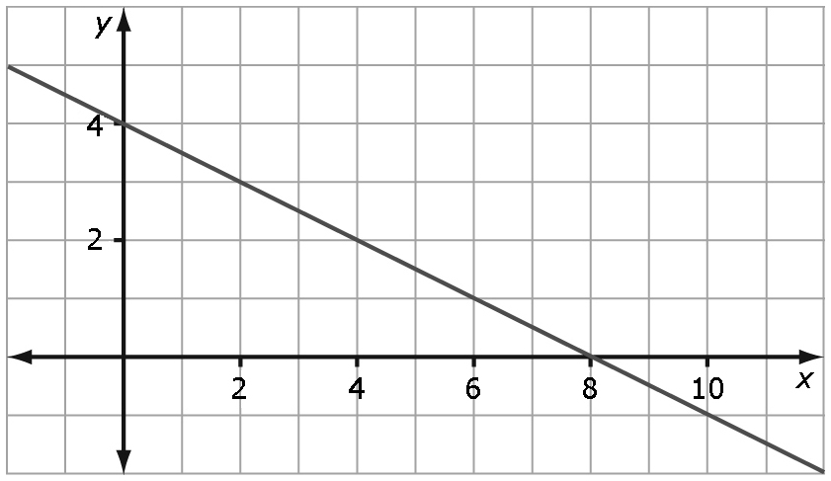

**8.** Determine the linear relation the graph on the left.   
UNIT #5 POLYNOMIALS



Let  represent +*x*2, represent +*x*, represent +1, represent -*x*, and represent −1.



**1.** Which diagram represents the expression *x*2 – 3*x* + 2?

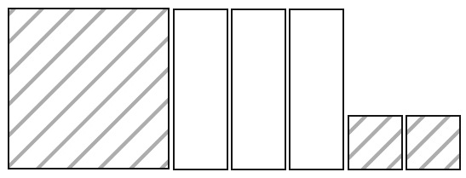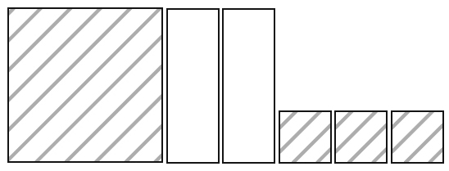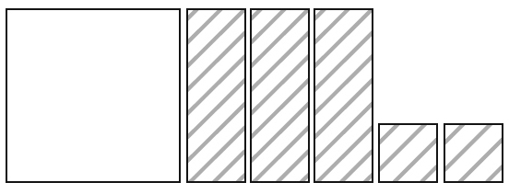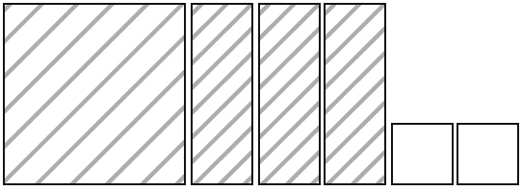**A B C D**

**B**

**2.** Which expression is an example of a polynomial with a degree of 2?

**A** 2*x* **B** 4 – 3*x* **C** 3*xy* + 5*x* **D** *x*2*y* + 3*x* + 7

**3.** Which expression can be classified as a trinomial?

**A** *x*2*y* + *xy*2 + *x* + *y* **B** *x* + *y* + *z* **C** 5*x*3 + 7 **D** 3*x*

**4.** Devin was asked to subtract the expressions 5*x* – 7 and –2*x* + 6. His work is shown below.

(5*x* – 7) – (–2*x* + 6) Step 1

= 5*x* – 7 + 2*x* + 6 Step 2

= 5*x* + 2*x* – 7 + 6 Step 3

= 7*x* – 1 Step 4

In which Step did Devin make his first mistake?

**A.** Step 1 **B**. Step 2 **C.** Step 3 **D.** Step 4

**5.** The degree of the constant term 6 is ________.

**6.** The coefficient of the term *x* is ________.

**7.** In the monomial –5*x*2, the variable is ________.

**8.** Write an expression that can be represented by the diagram shown.

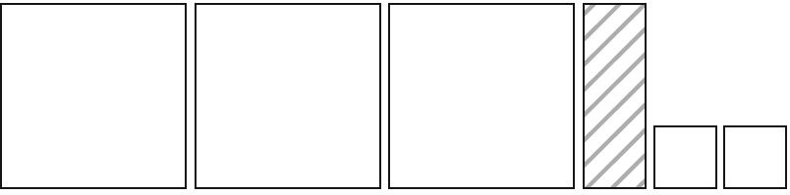

**9.** Match each expression on the left with its equivalent expression or model.

|  |  |  |
| --- | --- | --- |
|  | **a)** 4*x* + 11 – 5 – 6*x* | BLM5-11-6**A** |
|  | **b)** *x* – 2*x*2 + 4 | BLM5-11-7**B** |
|  | **c)** 3*x*2 – 1 + 5*x* + 3 – *x*2 – 4*x* | **C** –2*x* + 5 |
|  | **d)** –(–5 + 2*x*) | **D** –2*x*2 + *x* + 4 |

**10.** For the expression (2*x*2 – 3*x* + 1) + (–*x*2 + 5*x* + 2), draw a model to represent sum of the two polynomials. Then, express the sum symbolically.

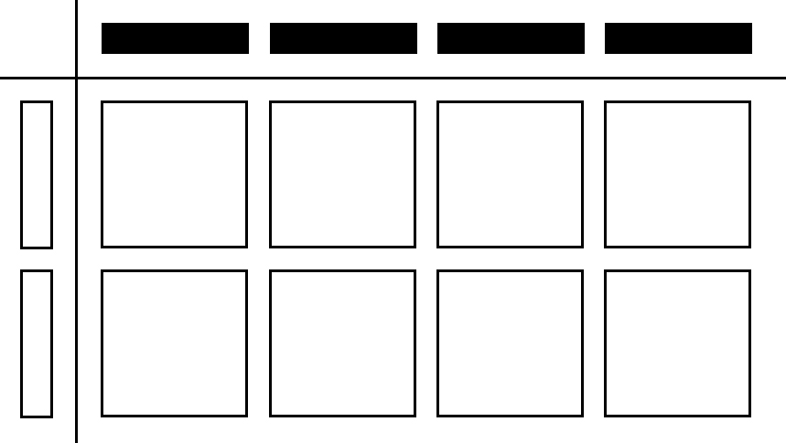

**11.** Which monomial multiplication equation is modelled by the algebra tiles?

**A** (–2*x*)(4*x*) = –8*x*2 **B** (–2*x*)(4*x*) = 8*x*2

**C** (–2*x*)(4*y*) = –8*xy* **D** (–2*x*)(–4*y*) = 8*xy*

**12.** Four students were asked to determine the quotient of the expression . Which student showed a correct partial solution?

**A** Amir: (16 ÷ 4) + (*x*2 ÷ *x*) **B** Brendan: (16 ÷ 4) ÷ (*x*2 ÷ *x*)

**C** Christina: (16 – 4) ÷ (*x*2 – *x*) **D** Dana: (16 ÷ 4) × (*x*2 ÷ *x*)

**13.** Leah simplified the expression . Which of the following classifications describes the quotient?

**A** monomial **B** binomial **C** trinomial **D** constant

**14.** Which of the equations best shows the use of the distributive property?

**A** 3(4*x +*2*x*) = 3(6*x*) **B** 5(2 – 3*x*) = 5(–3*x +* 2)

**C** 2(–*x* + 4) = (–*x* + 4)2 **D** 4(2*x* – 7) = (4)(2*x*) + (4)(–7)

**15.** The product (–3.7*x*)(5.1*y*), in simplified form, is __________________________

**16.** The quotient 10*x*2÷ 4*x*, in simplified decimal form, is _______________________________

**17.** Multiplying the polynomial *x* – 6 by 5*x* produces the expression ___________________

**18.** Write each product in simplified form.

**a)** (5*x*)(3*x*) **b)** (–4*x* + 5) (–2*y*)

**19.** Write each product in simplified form.

**a)**  **b)** 

**20.** Use a model to determine the product of 2*x* – 1 and –2*x*.

**21.** Sergio wanted to determine 5*x*(7*x* – 2). His solution is shown below.

(5*x*)(7*x*) + (5*x*)(–2) Step 1

= (5)(7)(*x*)(*x*) + (5)(–2)(*x*)(–2) Step 2

= 35*x*2 – 10(–2*x*) Step 3

= *x* 35*x*2+ 20*x* Step 4

Sergio discovered an error in his solution.

In which step did Sergio make the error? Show the correct solution.

UNIT #6 LINEAR EQUATIONS & INEQUALITIES

**1.** What is the solution for the equation –4(2*x* – 3) = –6?

**A**  **B**  **C**  **D** 

**2.** Andrea determined that the solution to the equation 6(3*x* – 1) = 4(4*x* – 5) is *x* = 7. Two possible methods for verifying Andrea’s solution are started below.

Method 1: Method 2:

4(4*x* – 5) = 6(3*x* – 1) 6(3*x* – 1) = 4(4*x* – 5)

16*x* – 20 = 18*x* – 6 6[3(7) – 1] = 4[4(7) – 5)

–2x = –14

**A** Method 1 is the best procedure to verify that Andrea’s solution is correct.

**B** Method 2 is the best procedure to verify that Andrea’s solution is correct.

**C** Method 1 is the best procedure to verify that Andrea’s solution is incorrect.

**D** Method 2 is the best procedure to verify that Andrea’s solution is incorrect.

**3.** Manuel was asked to solve the equation 2(8 – *x*) = 4(2*x* + 4) for *x*. His solution is shown below.

2(8 – *x*) = 4(2*x* + 4)

8 – *x* = 2(2*x* + 4) Step 1

8 – *x* = 4*x* + 8 Step 2

0 = 5*x* Step 3

The solution is undefined. Step 4

Which of the following would be a correct statement about the solution?

**A** There is an error in Step 1. **B** There is an error in Step 2.

**C** There is an error in Step 3. **D** There is an error in Step 4.

**4.** The solution to the equation 5*x* = 65 is ______.

**5.** The value of *y*, to the nearest tenth, that would make the equation  = 6.3 true is ______.

**6.** The solution to the equation  – 16 = 9 is ______.

**7.** The solution expressed in the form  for the equation  = 5*z* is ______.

**8.** Determine the solution for the variable in each of the following equations.

**a)** 7*x* – 19 = 86 **b)**  + 4 = –2

**c)** 5.6*x* = 3.2*x* + 13.2 **d)** –4*x* + 21 = –7*x* – 15

**9.** Mr. Lau asked his class to write an inequality to represent the solution set for the number line below.

|  |  |  |
| --- | --- | --- |
| BLM9-12 | **Erik** | *x* ≤ –5 |
| **Marissa** | *x* ≥ –5 |
| **Laurie** | –5 ≤ *x* |
| **Steven** | –5 ≥ *x* |

Which students correctly represented the solution set given by the graph?

**A** Erik **B** Erik and Steven

**C** Erik, Steven, and Marissa **D** All four students

**10.** Students were asked to create a problem where the solution set could be represented graphically by the diagram shown.

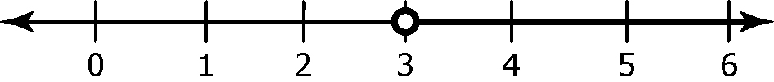

|  |  |
| --- | --- |
| **Ronald** | A number divided by –2 is greater than –. |
| **Thomas** | A number increased by 5, then doubled, is greater than 11. |
| **Jasmine** | The minimum value of 4 times a number, decreased by 5, is greater than or equal to 7. |
| **Stephanie** | A number multiplied by –6 is less than 18. |

Which student correctly wrote a problem with a solution set that could be represented by the given diagram?

**A** Ronald **B** Jasmine **C** Thomas **D** Stephanie

**11.** The solution set for the inequality 3(–2*x* + 15) < –21 is determined by solving for *x*. The solution is shown below.

Step 1 3(–2*x* + 15) < –21

Step 2 –6*x* + 45 < –21

Step 3 –6*x* > –66

Step 4 *x* < 11

Which of the following statements describes the given solution to the inequality?

**A** An error was made in Step 2. **B** An error was made in Step 3.

**C** An error was made in Step 4. **D** The steps are all correct.

**12.** Which rational number is a possible value of *x* for the linear inequality 3*x* – 3 < –9 – *x*?

**A**  **B**  **C**  **D** 

*Complete the statements in #5 to 7 by inserting the symbol* <, >, ≤, or ≥.

**13.** Given *x* + 5 ≥ 12, the solution set is *x* ____ 7.

**14.** For the inequality 3x – 2 < 12, the solution set is *x* ____ 5.

**15.** The solution set for –10 ≤ 5*x* + 10 is *x* ____ 4.

**16.** Your cell phone plan allows you to send up to 200 text messages per month for $5. Write an inequality to represent the number of text messages you can send for $5 per month.

**17.** Determine the solution set, in simplest form, for each of the following inequalities.

**a)** 4(2*x* – 1) < 16 **b)**  ≥ –

**18.** Draw a number line to represent the solution set for the linear inequality 3(2 – *x*) < 14 + *x*.

UNIT #7 SIMILARITY & TRANSFORMATIONS

**1.** Which figure has the largest number of lines of symmetry?

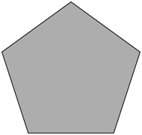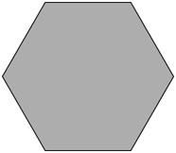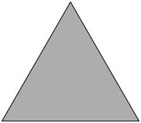**A** **B** **C** **D**

**2.** Both line symmetry and rotation symmetry are shown in which figures?

BLM 1-12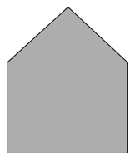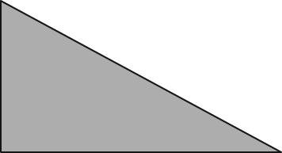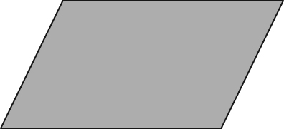**I** **II** **III** **IV**

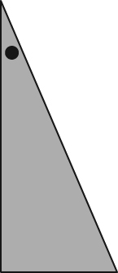**A** I and III **B** II and III **C** IV only **D** III and IV

**3.** The figure to the right was rotated about a vertex. Which image shows the resulting image?

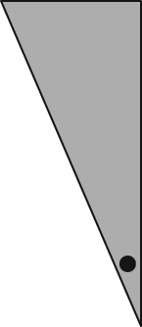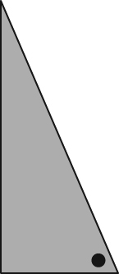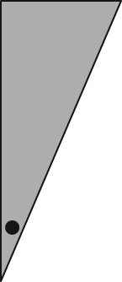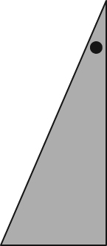**A** **B C D**

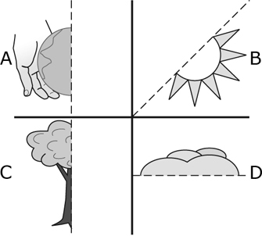

**4.** Imagine you complete each drawing (ON THE **LEFT**) using   
the given line of symmetry. Which drawing has rotation symmetry larger than two?

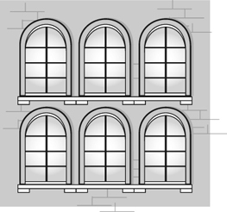

**5.** Which of the following statements is true when describing the picture to the right?

**A** There is a horizontal line of symmetry.

**B** There is an oblique line of symmetry.

**C** The line of symmetry is vertical.

**D** A line of symmetry does not exist.

|  |  |
| --- | --- |
| BLM1-12**6.** The order of rotation of the snowflake shown in the diagram is _______ | BLM 1-12**7.** If the diagram below is completed, the angle of rotation, rounded to the nearest tenth, is ______ ­­­­­ |

**8.** Jason arranged shapes into sets of similar   
polygons. How many of the shapes in the sets   
do not appear to be similar to any other shape?

**A** 5     **B** 4    **C** 3     **D** 0

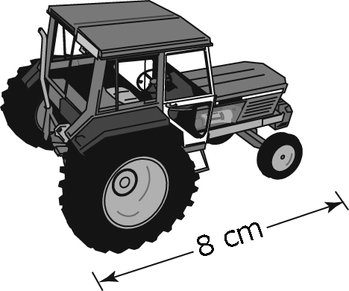**9.** A local farm equipment dealership has model   
tractors. The length of the actual tractor is 5.6 m.   
What scale factor was used for the reduction?

**A**     **B** 7    **C** 70    **D** 700

**10.** A penny has a diameter of 19 mm. Brenda used a scale factor of 3 to create a scale drawing of the penny. Which of the following statements about Brenda’s drawing is true?

**A** Brenda drew an enlargement. The drawing has a diameter of 57 mm.

**B** Brenda drew an enlargement. The drawing has a diameter of about 6.3 mm.

**C** Brenda drew a reduction. The drawing has a diameter of 57 mm.

**D** Brenda drew a reduction. The drawing has a diameter of about 6.3 mm.

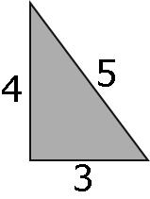

**11.** Which of the following triangles is similar to the given triangle?

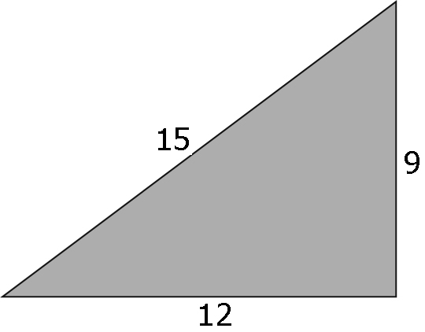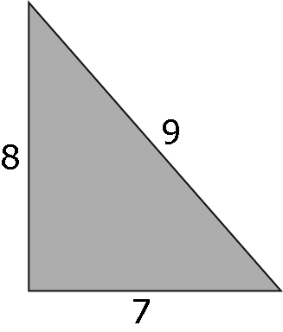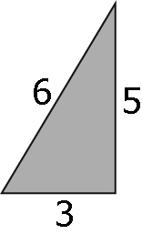 **A** **B**  **C D**

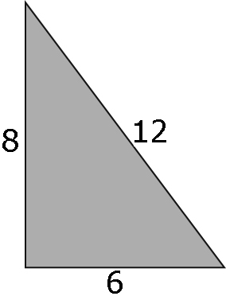

UNIT #8 CIRCLE GEOMETRY

**1.** The perpendicular from the centre of a circle to a chord ______________ the chord.

**A** bisects **B** intersects **C** is tangent to **D** passes through

**2.** Which of the following describes an inscribed angle in a circle?

**A** segments that have both endpoints on the circumference of a circle

**B** the angle formed by two chords that share a common endpoint on the circumference of a circle

**C** an angle formed by two radii of a circle where the endpoints are on the circle

**D** an angle where the vertex is inside the circle at the intersection of two chords

**3.** The measure of the central angle of a circle is ____________ the measure of an inscribed angle subtended by the same arc in the circle.

**A** twice **B** half **C** equal to **D** supplementary to

**4.** Which of the following describes a tangent to a circle?

**A** a line that intersects the circle at two points

**B** a chord that intersects the circle at two points

**C** a line that intersects the circle at only one point

**D** a chord that intersects the circle at only one point

|  |  |
| --- | --- |
| BLM10-13 | **5.** If the measure of ∠AOD is 86°, then the measure of ∠ACD is ____. |
| **6.** The measure of ∠ABD is ____. |

|  |  |
| --- | --- |
| BLM10-13 | **7.** What is the measure of ∠ACB? |

|  |  |
| --- | --- |
| **9.** In the diagram,  is tangent to the circle.The length of  is 24 cm and the length of  is 10 cm.  BLM10-13 | **a)** What is the length of ? |
| **b)** What is the length of ? |

|  |  |
| --- | --- |
| BLM10-13**8.** The centre of the circle is O. Points A and B are tangent to the circle. | **a)** What is the measure of ∠PAO? |
| **b)** What is the length of ? |
| **c)** What is the measure of ∠BPO? |

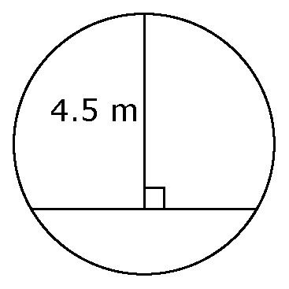**10.** A subway track must pass through a cylindrical tunnel. The tunnel is 6 m in diameter. How wide should the track bed be so that the maximum height at the centre of the tracks is 4.5 m? Express your answer to the nearest tenth of a metre.

**ANSWER KEY**

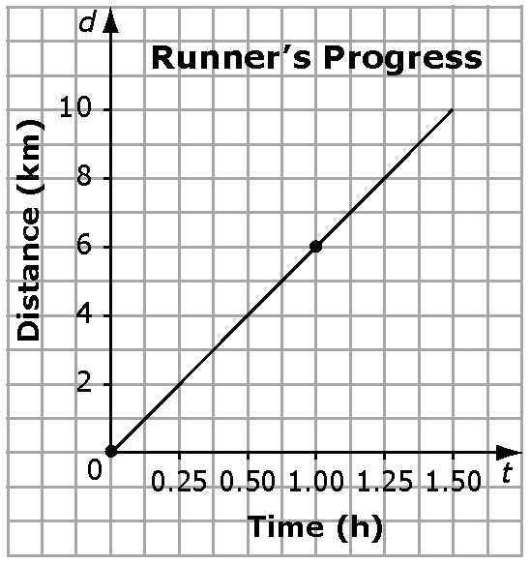

**UNIT #1**

**1. a)** 0.6 **b)** 8.0

**2. a)**  **b)**  **3.** 4 and 5 **4.** 5.29

**5. a)** No **b)** Yes,  ×  **c)** Yes,  ×    
**d)** Yes, 0.9 × 0.9 **e)** No **f)** Yes, 1.2 × 1.2

**g)** Yes, 0.01 × 0.01 **h)** Yes,  × 

**6.** *S.A.* (cube) = 600 cm2

*S.A.* (cylinder) = 1256.6 cm2

**7.** 162 –symbol-282 = 256; 256 – 201.06 = 54.94 cm2

**8**. 936 m2.

**UNIT #2**

**1.** B **2.** C **3.** D **4.** A **5.** A **6.** 28   
**7.**  **8.** –(4)3, (–1)5, 23, (–4)2

**9. a)** 3 × 3 × 3 × 3 × 3 × 3 × 3

**b)** (–1) × (–6) × (–6) × (–6) × (–6) × (–6)

**c)** 4 × 4 × 4 × 5 × 5 × 5

**10. a)** 63 **b)** 74 **c)** 212

**UNIT #3**

**1.** A **2.** B **3.** A **4.** D

**5.** 0.7, 0.8 **6.** 7.4

**7. a)**   
**b)** 

**c)**   
**d)** 

**e)**    
**f)** 

**g)** 

**h)** 1/6  
**8. a)** 17, –3.606,  **b)** –0.2, , , 

**UNIT #4**

**1.** D **2.** A **3.** 9 **4**.–6

**5.** *C* = 7 + 0.03*p*

**6.** a)*e* = 50 + 0.75*t*

**b)** Example: Left Side = 87.50;   
Right Side = 50 + 0.75(50) = 87.50;   
Left Side = Right Side

**7. a)**

**b)** 1 h 40 min**8. **

**UNIT #5**

**1.** A **2.** C **3.** B **4.** B

**5.** 0 **6.** 1 **7.** *x* **8.** –3*x*2 + *x* – 2

**9. a)** B **b)** D **c)** A **d)** C

**10.**Striped shapes are positive.

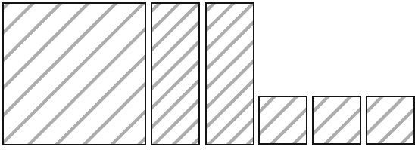

*x*2 + 2*x* + 3

**11.** A **12.** D **13.** B **14.** D

**15.** –18.87*xy* ***1*6.** 2.5*x* ***1*7.** 4*x*2 – 30*x*

**18. a)** 15*x*2 **b)** 8*xy* – 10*y*

**19. a)** 9*x* **b)** –8 + 2*x*

**20.** Model should show –4*x*2 + 2*x*.

**21. a)** Step 2

**b)** (5)(7)(*x*)(*x*) + (5)(–2)(*x*) = 35*x*2 – 10*x*

**UNIT #6**

**1.** C **2.** D **3.** D

**4.** 13 **5.** 2.7 **6.** –200 **7.** 

**8. a)** 15 **b)** –9 **c)** 5.5 **d)** –12

**9.** B **10.** B **11.** B **12.** A **13.** ≥ **14.** < **15.** ≥   
**16.** *x* ≤ 200 **17. a)** *x* < 2 **b)** *x* ≤ –

**18.**

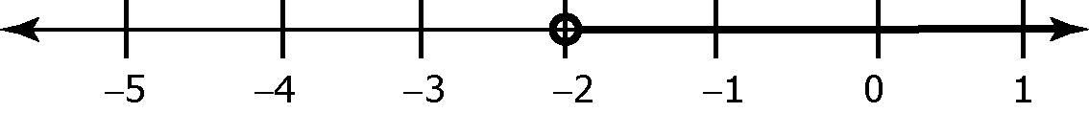

**UNIT #7**

**1.** B **2.** C **3.** D **4.** B **5.** C

**6.** 6 **7.** 25.7º

**8.** B **9.** C **10.** A **11.** D

**UNIT #8**

**1.** A **2.** B **3.** A **4.** C

**5.** 43° **6.** 43° **7.** 42°

**8.** **a)** 90° **b)**  or 3.9 **c)** 25°

**9. a)** 26 cm **b)** 16 cm

**10.** 5.2 m