Similar Figures Puzzle
taken from http://homepages.math.uic.edu/~saunders/workshop_geometry/similarity2009.pdf

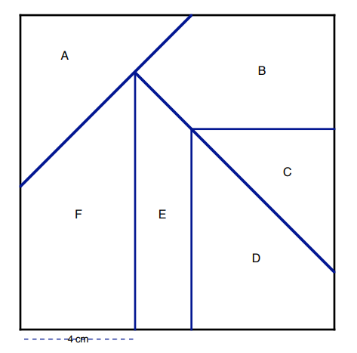
Make an enlargement of your piece so that the length that is currently labelled 4 cm becomes 6 cm (or another value defined by your teacher). Your classmates will be assigned to enlarge the other pieces. When you are all finished, your class/group will put your pieces back together. If the pieces fit together properly, congratulations! If the pieces do not fit, explain what went wrong (you may wish to include diagrams and/or calculations) on a separate piece of paper and hand it in.

