NUMBERS AS SHAPES-DO THIS IN YOUR DUOTANG

Here are the numbers 1 to 6 drawn on a grid. Notice that each “number shape” is made of the same number of small squares as its “name”.
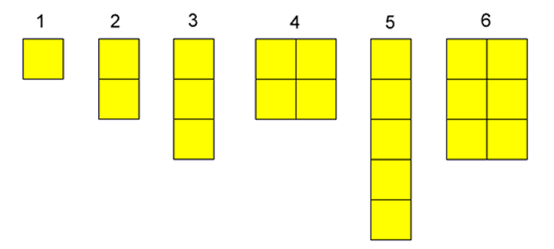
On the grid paper provided, draw out the numbers to 20.

We can call these numbers squares, rectangles or sticks.

Notice that:

1 is a square but just a single one.
We can't make 2 into a square so 2 is a stick.
We can't make 3 into a square or a rectangle so 3 can only be a stick.
We can make 4 into a square.
We can't make 5 into a square or a rectangle, so 5 can only be a stick.
We can't make 6 into a square, but we can make 6 into a rectangle.

Try this with the numbers up to and including 20.

Which ones can only be sticks?
Which ones can make rectangles?
Which ones are squares?

Are there any numbers that can be more than one shape? Which ones? Which shapes?

Try to explain why some numbers can only be one shape while others can be more than one shape.

